QTP
OUTPUT VALUES



Guided By: Submitted By:
Utpal Sardar Yogesh Tiwari
Krishna Goswami

Table of contents-
1. What Is Output Values.
2. Output Values Description.
3. Ways to Create Output Values.
5. Example.

What Is Output Value?
“An Output value step is a step in which one or more values are captured at a specific point in your test and stored for the duration of the run session. The values can later be used as input at a different point in the run session.”

Output Value Description
Using Output values we can retrieve properties of objects,database field values, text presenting objects and can store on data table in test result window
There are seven types of checkpoints in QTP 11 version:
1.Standard Output Values: We can use standard output values to output the properties values of most objects. For Example- In a Web-based application, the number of links on a Web page may vary based on the selections a user makes on a form on the previous page. You could create an output value in your test to store the number of links on the page.
2.Text Output Values: You can use text output values to output text strings displayed in an application. When creating a text output value, you can output a part of the object’s text. You can also specify the text before and after the output text. For example- Suppose that you want to store the text of any error message that appears after a specific step in the Web application you are testing.
3.Text Area Output Values: Text area output values to output text strings displayed within a defined area of a screen in a Windows-based application.You can create a text area output value only while recording on Windows-based applications. For example- Suppose that you want to store the text of any error message that appears after a specific step in the window application you are testing.
4.Database Output Values: We can use database output values to output the value of the contents of database cells, based on the results of a query (result set) that we define on a database.For Example - You can create output values from the entire contents of the result set, or from a part of it. During the run session, QuickTest retrieves the current data from the database and outputs the values according to the settings that you specified.
5.XML Output Values: We can use XML output values to output the values of XML elements and attributes in XML documents.For Example - Suppose that an XML document in a Web page contains a price list for new cars. You can output the price of a particular car by selecting the appropriate XML element value to output.

Ways To Create Output Values
There are 4 ways to create Output Values in QTP.
1.We can create a checkpoint at the recording time of application.
Goto Insert MenuàOutput ValuesàThen Select the type of Output Values.
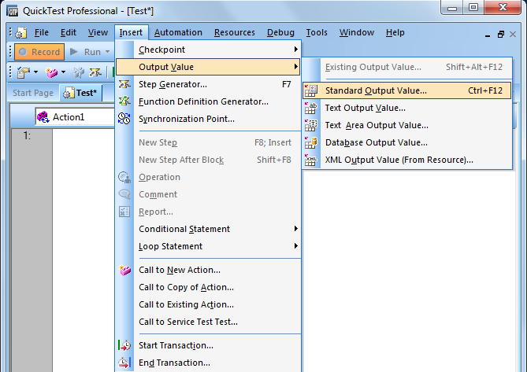

1. We can create Output Values by Expert view.
We have to put here manualy by code-
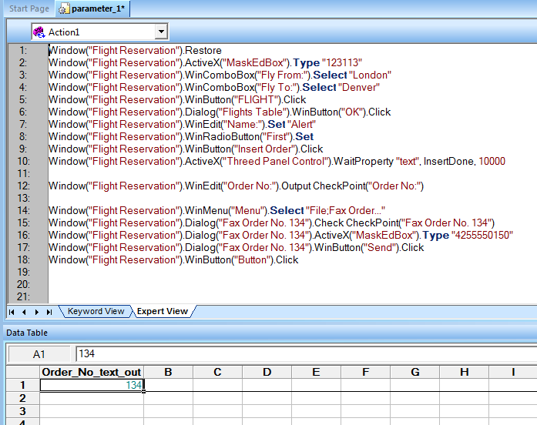
3. We can create Output Values by Keyword View.Goto Keyword view Select ObjectàClick Value Coloumn of object 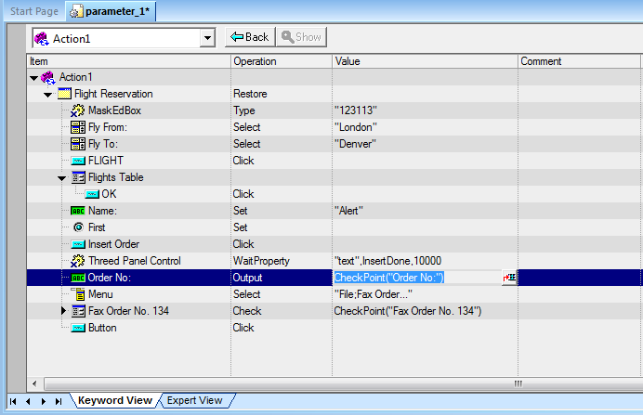
4. We can create Output Values by Active Screen Also.
Right click on object.
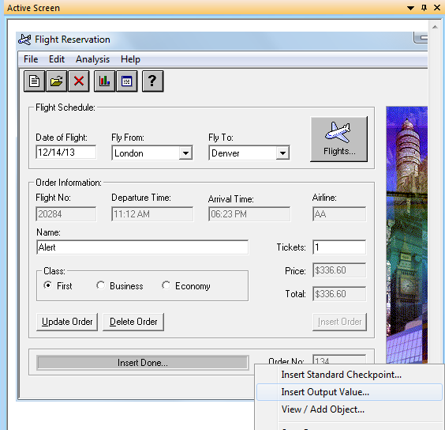

Example
Create a Checkpoint on order no
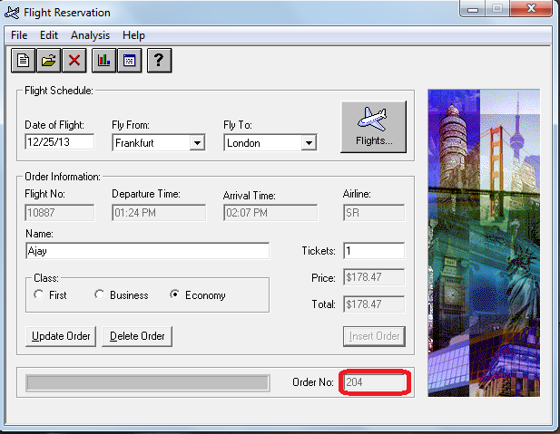

- Goto INSERTà OUTPUT VALUES àSTANDARD OUTPUT VALUES.
- In Active Screen Right Click On Order No Field and Select
STANDARD OUTPUT VALUES PROPERTIES Dialog Box Apears-
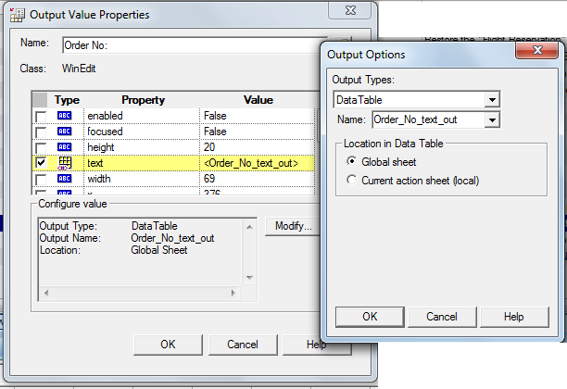
- We can also open OUTPUT VALUES Properties Dialog Box By Keyword View-
- After Run The Script We can Observe the Test Results.
